**Image Augmentation** is a very simple, but very powerful tool to help you avoid overfitting your data. The concept is very simple though: If you have limited data, then the chances of you having data to match potential future predictions is also limited, and logically, the less data you have, the less chance you have of getting accurate predictions for data that your model hasn't yet seen. To put it simply, if you are training a model to spot cats, and your model has never seen what a cat looks like when lying down, it might not recognize that in future.

Augmentation simply amends your images on-the-fly while training using transforms like rotation. So, it could 'simulate' an image of a cat lying down by rotating a 'standing' cat by 90 degrees. As such you get a cheap way of extending your dataset beyond what you have already.

To learn more about Augmentation, and the available transforms, check out <https://github.com/keras-team/keras-preprocessing> -- and note that it's referred to as **preprocessing** for a very powerful reason: that it doesn't require you to edit your raw images, nor does it amend them for you on-disk. It does it in-memory as it's performing the training, allowing you to experiment without impacting your dataset.

**2.1 Introducing augmentation**

When using convolutional neural networks, we've been passing convolutions over an image in order to learn particular features.

You can see more about the different APIs at the Keras site here:

<https://keras.io/preprocessing/image/>

**2.2 Coding augmentation with ImageDataGenerator**

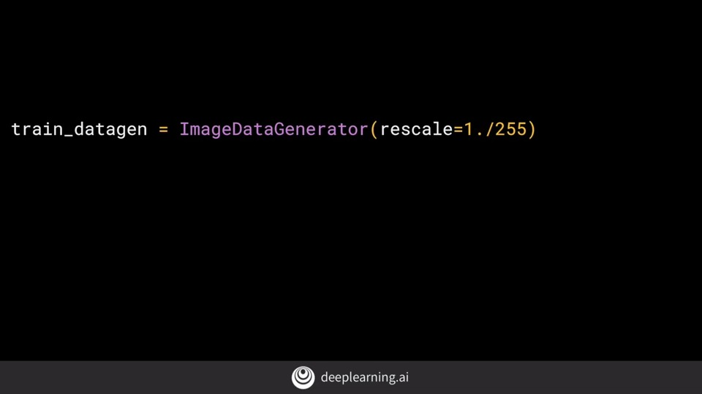

Here's how you could use a whole bunch of image augmentation options with the image generator adding onto re-scale.

**Rotation range** is a range from 0-180 degrees with which to randomly rotate images. So in this case,the image will rotate by random amount between 0 and 40 degrees.

**Shifting**, moves the image around inside its frame. Many pictures have the subject centered. So if we train based on those kind of images, we might over-fit for that scenario. These parameters specify, as a proportion of the image size, how much we should randomly move the subject around. So in this case, we might offset it by 20 percent vertically or horizontally.

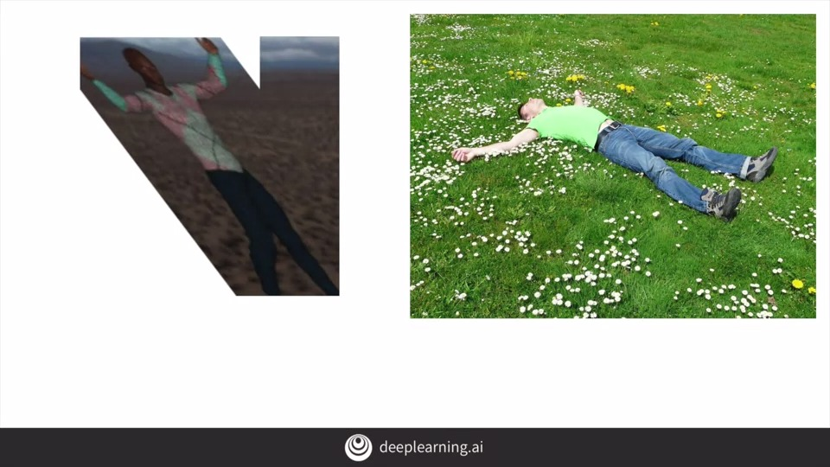

**Shearing** is also quite powerful. So for example, consider the image on the right. We know that it's a person. But in our training set, we don't have any images of a person in that orientation. However, we do have an image like this one, where the person is oriented similarly. So if we shear that person by skewing along the x-axis, we'll end up in a similar pose. That's what the shear_range parameter gives us. It will shear the image by random amounts up to the specified portion in the image. So in this case, it will shear up to 20 percent of the image.

Zoom can also be very effective. For example, consider the image on the right. It's obviously a woman facing to the right. Our image on the left is from the humans or horses training set. It's very similar but it zoomed out to see the full person. If we zoom in on the training image, we could end up with a very similar image to the one on the right. Thus, if we zoom while training, we could spot more generalized examples like this one. So you zoom with code like this. The 0.2 is a relative portion of the image you will zoom in on. So in this case, zooms will be a random amount up to 20 percent of the size of the image.

Another useful tool is **horizontal flipping**. So for example, if you consider the picture on the right, we might not be able to classify it correctly as our training data doesn't have the image of a woman with her left hand raised, it does have the image on the left, where the subjects

right arm is raised. So if the image were flipped horizontally, then it becomes more structurally similar to the image on the right and we might not over-fit to right arm raisers. To turn on random horizontal flipping, you just say horizontal_flip equals true and the images will be flipped at random.

Finally, we just specify the **fill mode**. This fills in any pixels that might have been lost by the operations. I'm just going to stick with nearest here, which uses neighbors of that pixel to try and keep uniformity. Check the carets documentation for some other options. So that's the concept of image augmentation.

**2.3 Demonstrating overfitting in cats vs. dogs**

Cats-v-Dogs-Augmentation.ipynb

**2.4 Adding augmentation to cats vs. dogs**

Cats-v-Dogs-Augmentation.ipynb

**2.5 Exploring augmentation with horses vs. humans**

Horse-or-Human-WithAugmentation.ipynb